|  |
| --- |
| Assignment#1: Product Roadmap, Release Plan and Story Map |
| Key |

PLease refer to the scenario CRM Sales Managemement software and crearte a prodcut roadmap, release plan and story map in Jira or any othe agile tool.

guidelines to be followed:

* refer to the elevator pitch and understand what are some of the uniq features that the crm innovator product should have.
* define the mvp (minimal viable product)
* come up with release plan post mvp that will add incremental value to the product
* discuss in the team why do you recommend specific features in specific relesase
* understand the different roles and their needs for crm sales and marketing software that the product should fulfill.

**prodcut roadmap**

The product roadmap created in jira.

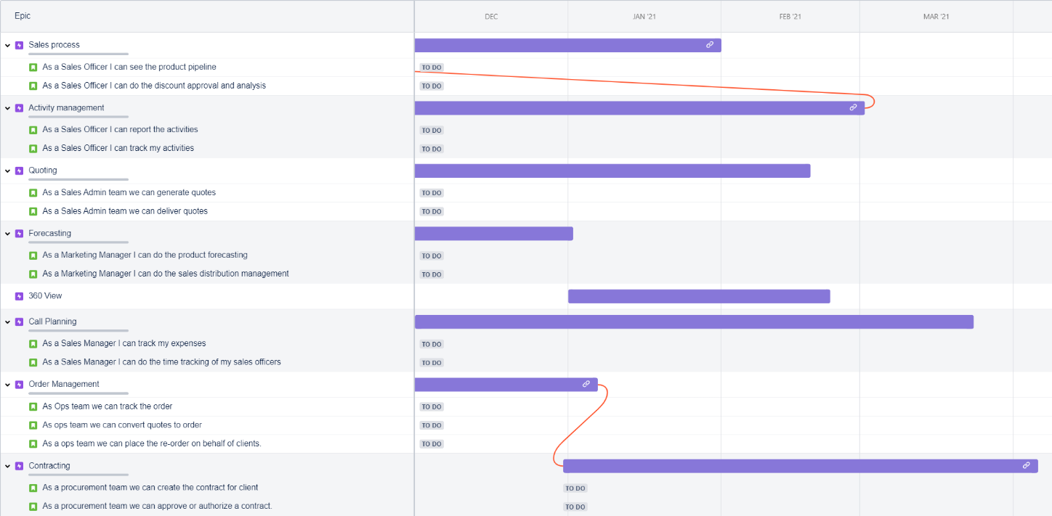

release plan

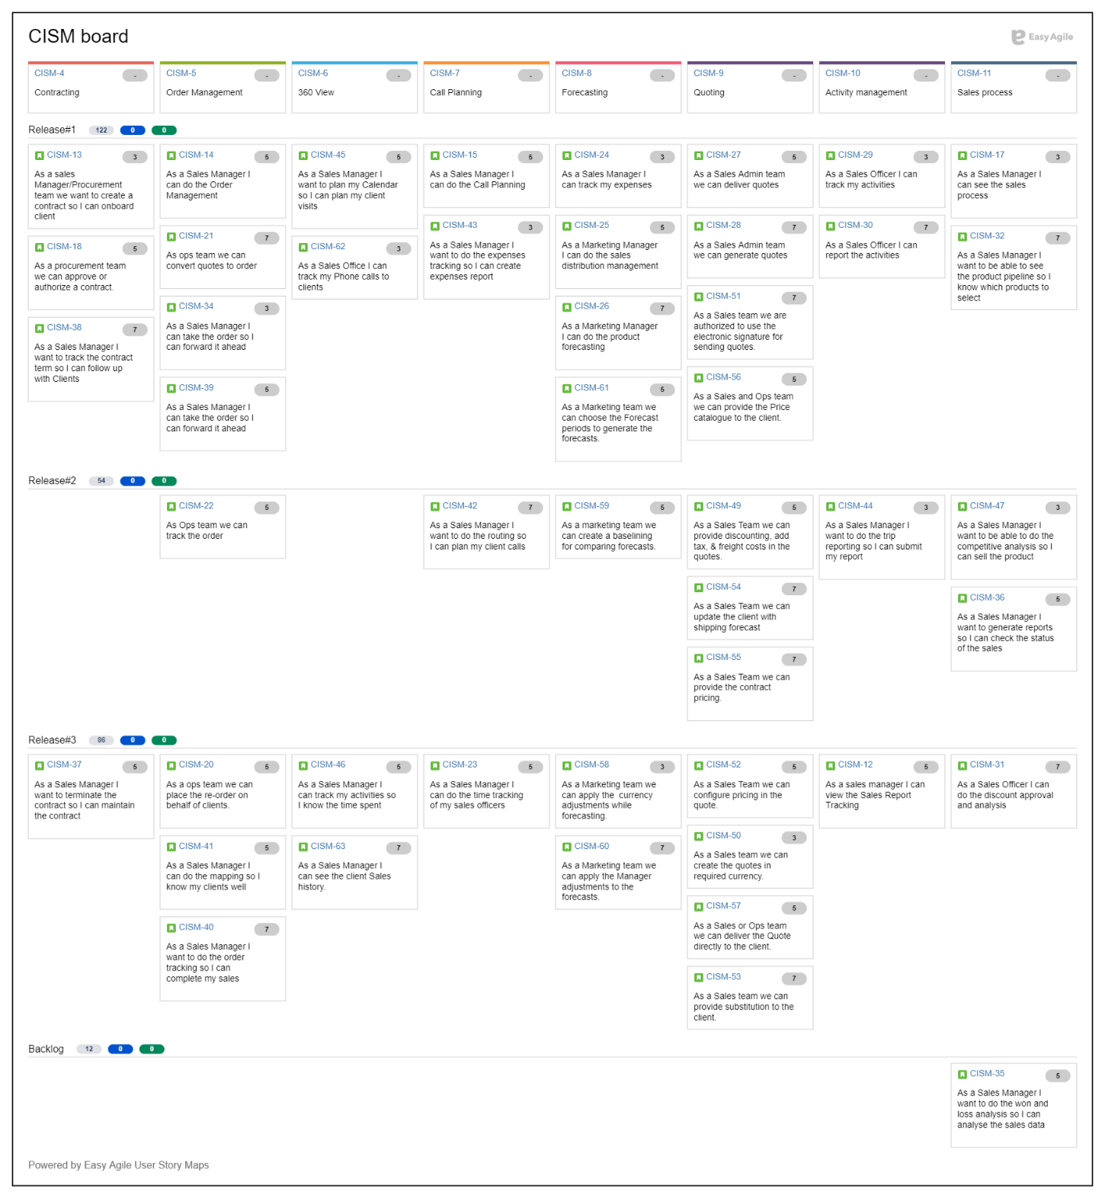

story map

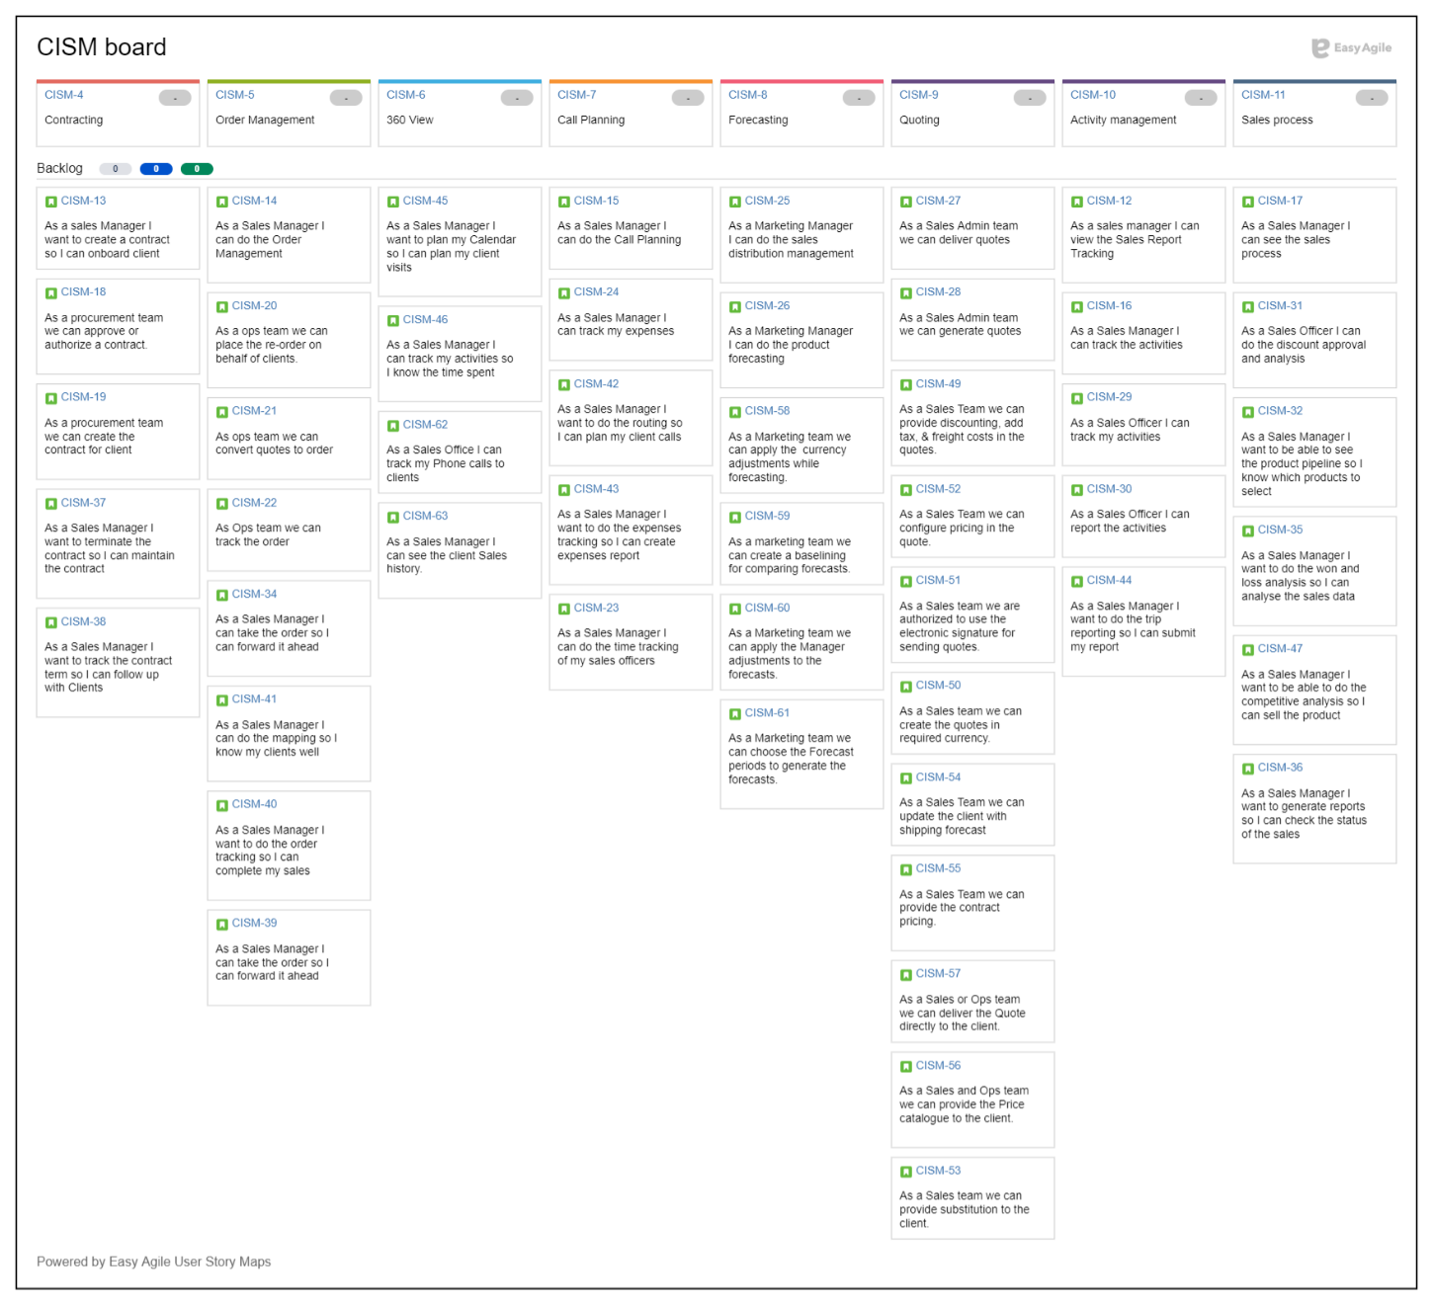

Story map by sprint swimlanes

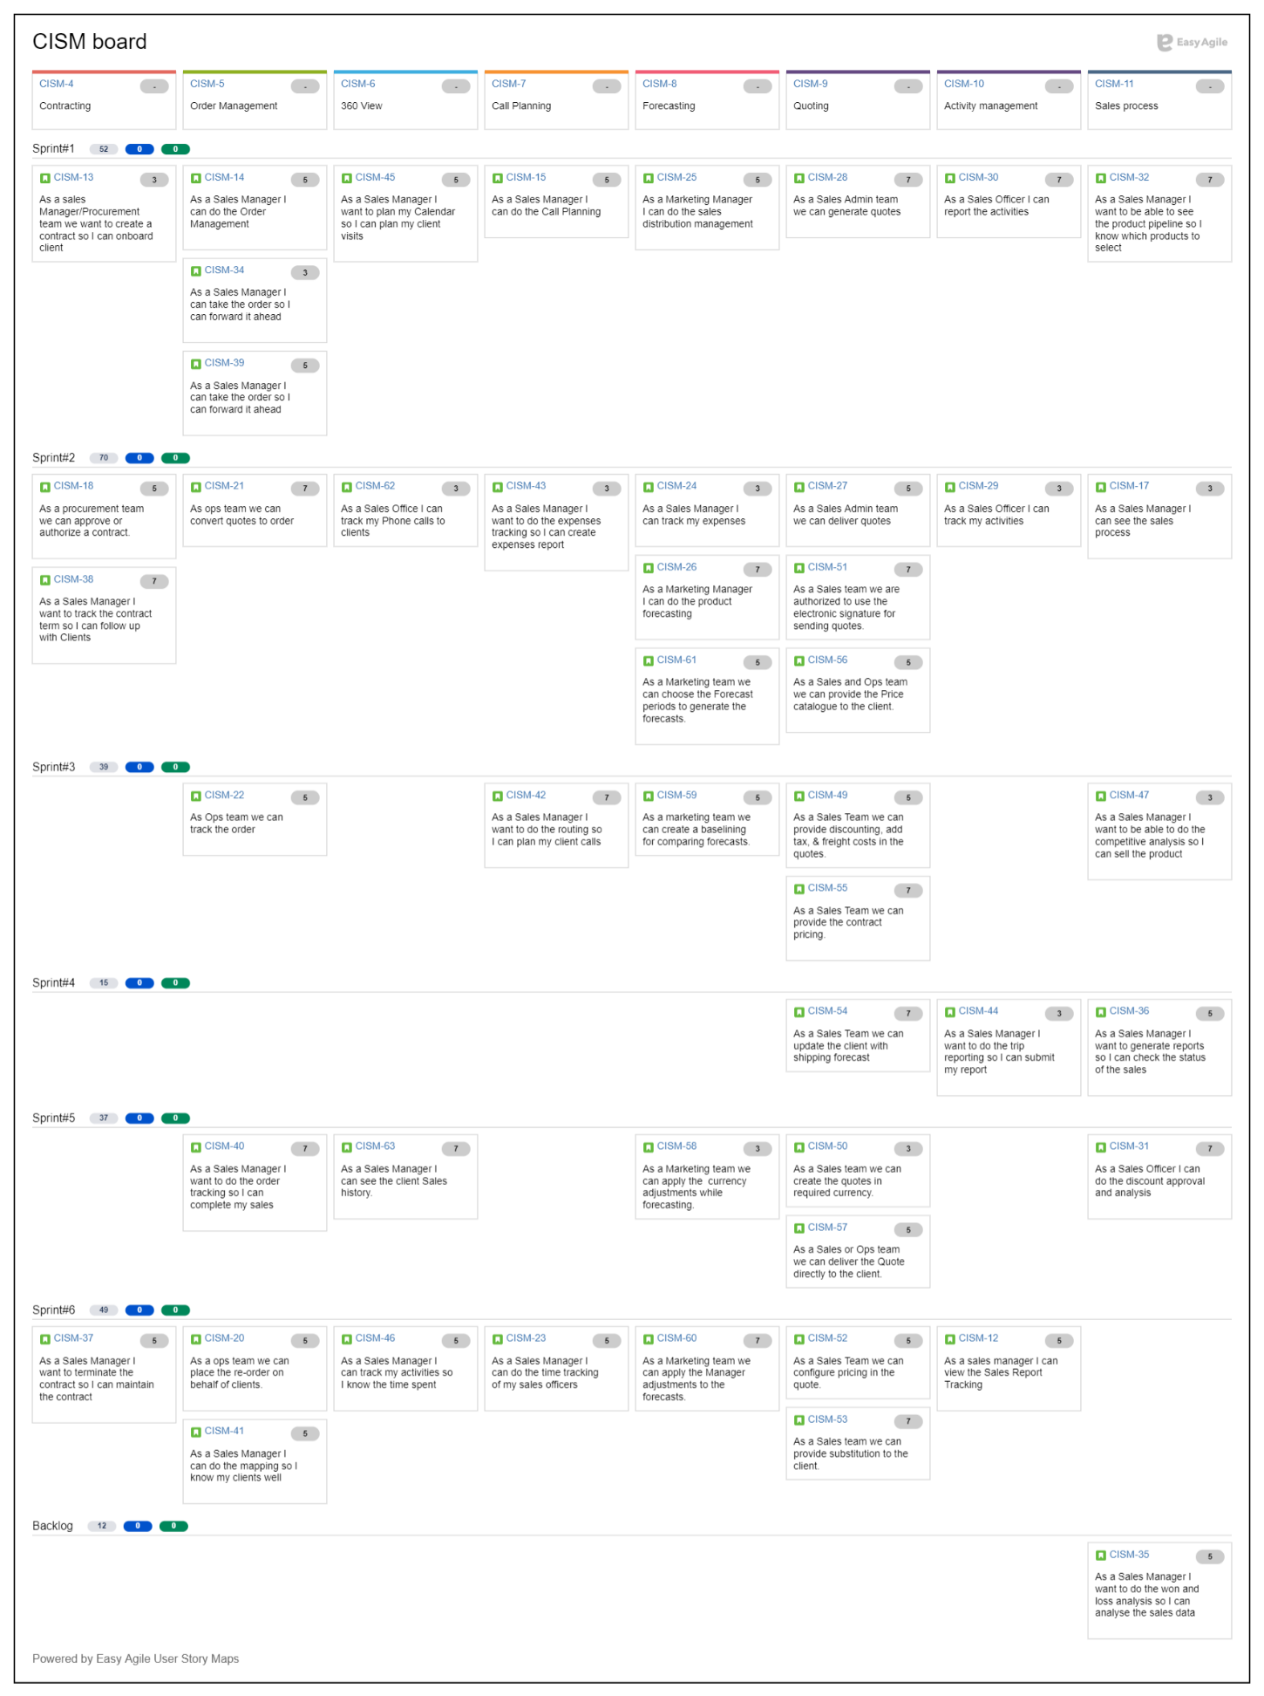

Story map by release/version swimlanes

